Print numbers from 1 to 10 using a for loop.

Print all even numbers from 2 to 20 using a for loop.

Print the square of each number from 1 to 10.

Print each letter of a given word (e.g., "Python") on a new line.

Find the sum of numbers from 1 to 10 using a for loop.

Print the multiplication table of a given number (e.g., 5).

Reverse a given word using a for loop.

Find the factorial of a given number (e.g., 5!).

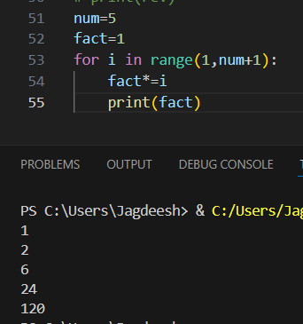

Print a simple pattern like a right-angled triangle using "\*".

Count the number of vowels in a given word.

